Lab 2: Odometry and Error Measurements
Lab Report

David Ersek
Harvey Mudd College
Claremont, California USA
dersek@hmc.edu
Paula Ning
Harvey Mudd College
Claremont, California USA
pning@hmc.edu

Abstract—The Jaguar Lite can move by means of a control loop between the robot and a machine running code. An onboard laser range-finder allows the Jaguar Lite track how close it is to an obstacle directly in front of it. By using data from the range-finder as feedback, it is possible to implement a closed-loop control system which would autonomously position the robot at a specified distance away from any obstacle before it.
Keywords—robotics, autonomous navigation, range-finder, closed-loop control

Introduction
The Jaguar Lite robot by Dr Robot has several features to improve control and navigation. Among these are: a GPS module, a laser range finder, an inertial measurement unit (IMU), and a front-facing camera. Two variable actuators control the robot’s tracks, allowing it to move. The robot allows wireless remote control over a Wi-Fi transmitted from an on-board router. In this lab, software was used to remotely control the robot’s actuators based on data taken from the laser range finder.

Goals

Basic Navigation and Code Familiarity
Learning to control the robot through software was the first goal of the lab. While the provided code included a user interface to allow control of the robot’s actuators, the primary objective of this part of the lab was to understand the underlying functions and variables involved in directing the robot with no human input. The secondary objective was to learn the various features of the given user interface. Deliverables for this goal include changes to the interface’s behavior, as well as a log file demonstrating that the robot’s estimated position can be updated in software.

Positioning the Robot
The second goal of the lab provided the main problem for the lab – to write code that would direct the robot to position itself one meter away from a wall within a tolerance of 20cm. The code should allow the robot to reach such a position without human interaction after the laser scanner had been activated and the robot had been put into autonomous mode. A robot would successfully complete this goal if, after being positioned some arbitrary distance from a wall or obstacle and set into autonomous mode with the range finder operating, the robot ran until it stopped where the center value of the laser range finder read one meter (± 20cm) to the closest obstacle. For this challenge, the robot was not judged on its ability to circumnavigate obstacles that the center value of the laser range finder did not detect. The center value of the laser range finder was considered to measure the distance from the range finder to an obstacle at an angle of 0° from the robot’s front.

Control Design

Basic closed-loop control
As previously stated, one of the objectives of this lab was to have the robot autonomously position itself one meter away from a wall. To accomplish this, the provided code was extended to implement a closed-loop control system which would control the velocity of the robot based on feedback from the laser rangefinder. This control system—which is implemented as the WallPositioning() function in the Navigation.cs file—is called in each iteration of the main control loop. Each time the WallPositioning() function is called, it samples the center value of the laser rangefinder to find the distance between the robot and the wall. If this distance is within error (20 cm) of the target distance (1 m), the velocity of both tracks is set to 0. Otherwise, the robot moves towards the target distance at the minimum possible speed.

Additional control loop modifications
In trials using the original control system, it was observed that the robot would sometimes overshoot the target position. In order to address this problem, the main control loop was modified such that the robot would be stopped shortly after the WallPositioning() function is called. This means that the velocity is non-zero for only a short period of time before the next update. Then, the robot moves in short bursts, at an average velocity that is slower than the minimum velocity of the robot.

Results

Basic closed-loop control
As mentioned earlier, the robot would sometimes overshoot its target position. This is because the minimum possible speed of the robot is still fast enough to move a distance larger than the error margin (40 cm) within the time delay of a single iteration of the main control loop (approximately 1/20th of a second). This means that it is possible for for the robot to overshoot the target before the rangefinder data can update. When the robot overshoots, it sees that it has passed the target, and changes direction to move towards the target once more. This behavior may be seen in three of the graphs in Figure 1.
Despite these issues with overshoot, the robot was able to reach a final position within 20 centimeters of the target in all attempted trials.

Modified closed-loop control
With the modified closed-loop control system, the robot moved at a slower average velocity. This is indicated by the shallower steps in distance in Figure 2 as compared to Figure 1, and also the relatively longer time scale of Figure 2 as compared to Figure 1. Since the robot moved more slowly under the modified control system, it was less likely to overshoot the target position. This may be qualitatively observed by comparing the variance in final positions in Figure 1 with the variance in final positions in Figure 2.
However, this modification is not without drawbacks. Aside from taking longer to reach its final position, each time the robot stops and starts adds a small amount of error in the robot’s rotation. While this error is small if the robot only starts and stops once, it becomes noticeable when the robot is constantly stopping and starting.
Regardless, the modified closed-loop control is capable of arriving at the target position within error. Although only a few trials were carried out, qualitative observation suggests that the modified control system is less likely to overshoot- in fact, if the robot’s average velocity is such that it is impossible for the robot to move more than 40 cm before it gets stopped, it is impossible for the robot to overshoot. Furthermore, by comparing Figures 1 and 2, it seems that the margin of error for the modified control system is less than that of the basic control system, although further tests are required to rigorously confirm this observation.
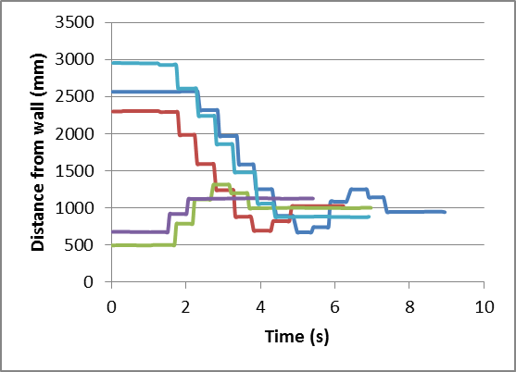
- Distance to wall vs. tiem for original control loop
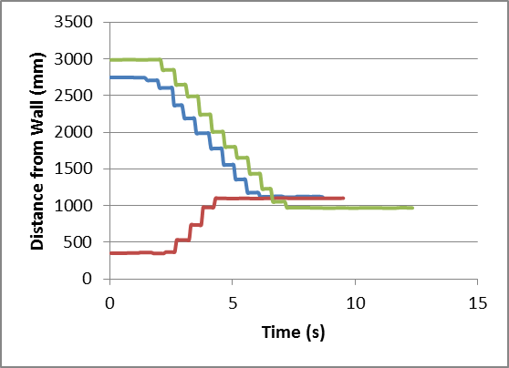
- Distance to wall vs. time for modified control loop

Conclusion
Using the basic control system, the robot was able to navigate to a target position within a designated tolerance of 20 cm. In order to achieve this, however, the robot would sometimes have to reverse direction to compensate for overshoot.
With the modified control system, the robot reached its target position more slowly and exhibited more rotational error. However, it was not observed to overshoot, and also reached the target position within the designated tolerance.
Each of the control systems have advantages and drawbacks such that their utility would depend on specific use cases, and so neither can be said to be truly superior to the other. However, both of them satisfy the objectives of this lab.

References
- Department of Engineering. (2013, Spring). E190Q – Autonomous Robot Navigation Lab 1.

